CSE 305 SOFTWARE ENGINEERING MIDTERM PROJECT

1-SYSTEM REQUIREMENTS

DUE DATE (13/11/2020)

181805080 ANIL DURMAZ

Team Name : SoftTouch

Project Title : KaraokeNight (Website Project)

SoftTouch Members

Anıl Durmaz 181805080

Betül Başan 181805028

Betül Şahin 201805002

Ferhat Kamalı 171805056

System Requriements

1. Internet connection is sufficient.
2. A site visitor should be able to view the homepage ,menu , drinks, photo gallery, rooms, events.
3. A site visitor should be able to add comment to the menu, drinks, photo gallery, rooms, events.
4. The admin should be able to organize the site.
5. The admin should be able to access the users comments.

KaraokeNight Website Use-Case Diagram

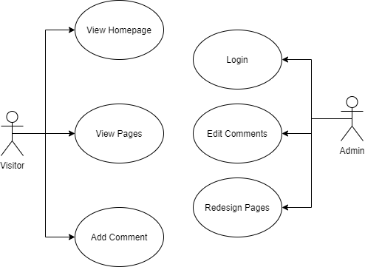

|  |  |  |  |  |  |
| --- | --- | --- | --- | --- | --- |
| User Story with Pre- and Post Conditions | | | | | |
| **Use case ID** | **Use case name** | **User story** | **Pre-condition** | **Standard flow** | **Post condition** |
| 1 | Login | As a site admin, I can login the admin panel so I can make some changes in site | - | 1- Admin opens the admin panel and admin enters “username” and “pasword”  2- The system queries the user name and password information from DB  3- If the information is correct. Admin can enter the administration panel. | Admin logged in |
| 2 | Add Comment | As a site visitor, I can post comments about contents so that others can read them. | Comment section exist on the sytem | 1- A site visitor writes a comment in the empty textbox where is bottom of the homepage.  2- And click the “Add comment” button and the sytem saves the comment in DB.  3- The site admin check the the comment for 3 days.  4- If there is nothing innapproiate in the comment, the comment is published. | System added comment |
| 3 | View Homepage | As a site visitor, I can look at the about, and other menus links on the home page so that I learn about the Karaokenight. | - | 1- A visitor click on “Home” tab and the homepage opens. | Homepage viewed |
| 4 | View Content  Pages  **(Epic)** | As a site visitor, I can look at the drinks, menu, rooms, events, photo gallery so that I learn about the Karaokenight options. | Content pages  exist on the system | 1- A visitor choose a content button.  2- The visitor click on content button that he/she wants . | Pages  viewed |
| 5 | Edit Comments  **(Epic)** | As a site admin, I can edit comments so that any problem about comments. | Login as a admin  Comments exist on the system | 1- A site admin click “Edit Comments” button where is on admin page.  2- The admin chooses any comment that have a problem in its meaning or content.  3- The visitor click on “delete comment” button.  4- The comment which was choosed by the admin is deleted from DB and the user interface. | Comment edited |
| 6 | Redesign Pages  **(Epic)** | As a site admin, I want to be able to designate site so that the best keep the site is up-to-date | Login as a admin | 1- A site admin click “edit pages” button on admin panel.  2- The admin choose a page that he/she wants to edit.  3- The admin redesigns, deletes the web page, add new button or new content, changes all of the web page contents. | Pages redesigned |

Nonfunctional Requirements

1. Performance

* Users reach the site at any time of the day.
* The website’s load time should not be more than one second for users.

1. Usability

* The website’s interface has to be user-friendly and easy to use.

1. Data Integrity

* The system shall maintain data integrity by keeping backups of all updates to the database for every record transaction.
* Swelling in the database should be prevented and information should be kept under constant control.

Dictionary of System Terms / Project Glossary

|  |  |
| --- | --- |
| **Term** | **Description** |
| Home | It is home page of the website. |
| Menu | It is the web page where the names, pictures, ingredients and price list of the food in our cafe are displayed. |
| Rooms | It is the web page with detailed information about the rented rooms in our cafe. |
| Events | It is the web page with detailed information about the activities in our cafe. |
| Drinks | It is the web page where the names, pictures, ingredients and price list of the drinks in our cafe are displayed. |
| About | It is the part that gives information about our cafe. |
| Photo Gallery | It is the photo gallery where you can see the photos taken in our cafe. |
| Comment | It is the section where you can comment on any product sold in our cafe or café. |
| Karaoke Night | It is name of the our cafe. |